- Problem + Algorithm
Experiment No.: 11
Title: Regularized Regression (L1 Lasso and L2 Ridge) for GDP per Capita Prediction
Aim:
Implement Linear, Lasso (L1), Ridge (L2) and Elastic Net regression on World Bank macroeconomic data, and study how the type and strength of regularization affect prediction error, coefficient size and feature selection.
Problem Statement:
Using the World Bank World Development Indicators panel (2010–2023), predict the natural log of GDP per capita (constant 2015 US$) of an economy from nine indicators: trade, capital formation, inflation, unemployment, FDI inflows, government consumption, industry value added, urban population and population growth. Because the predictors are correlated and the model must generalize to economies it has never seen, apply L1, L2 and Elastic Net penalties, tune their strength by country-grouped cross-validation, and compare them with an unregularized Linear Regression baseline on held-out economies.
Algorithm:
- Load the dataset; keep rows where the target is present and at least 6 of the 9 predictors are available.
- Take the natural log of GDP per capita to reduce skewness.
- Split the data by country (GroupShuffleSplit, 80/20) so that no economy is in both training and test sets.
- Build a pipeline: median imputation → standardization → model.
- Tune alpha (and l1_ratio for Elastic Net) using GridSearchCV with GroupKFold (5 folds) and RMSE scoring.
- Fit the best model of each type on the training set and evaluate on the unseen economies (log RMSE, MAE, R², median absolute percentage error).
- Compare coefficients, sparsity (nonzero coefficients) and norms of the four models.
- Vary alpha over a wide range to study validation error, shrinkage and the number of active predictors.
- Report the best model and conclusion.
- Program
Important code sections, function definitions, core algorithm and key parameter settings are given below. The complete executable program (Q11_L1_L2.ipynb) can be maintained digitally through GitHub.
Libraries and key parameter settings
import numpy as np, pandas as pd, matplotlib.pyplot as plt
from sklearn.impute import SimpleImputer
from sklearn.linear_model import ElasticNet, Lasso, LinearRegression, Ridge
from sklearn.metrics import mean_absolute_error, mean_squared_error, r2_score
from sklearn.model_selection import (GridSearchCV, GroupKFold, GroupShuffleSplit,
cross_val_score)
from sklearn.pipeline import Pipeline
from sklearn.preprocessing import StandardScaler

RANDOM_STATE = 42
DATA_PATH = "world_bank_macro_2010_2023.csv"
FEATURES = ["trade_pct_gdp", "gross_capital_formation_pct_gdp",
"inflation_consumer_pct", "unemployment_pct", "fdi_net_inflows_pct_gdp",
"government_consumption_pct_gdp", "industry_value_added_pct_gdp",
"urban_population_pct", "population_growth_pct"]

Data preparation and country-wise split
raw = pd.read_csv(DATA_PATH)
target = "gdp_per_capita_constant_2015_usd"
data = raw.loc[raw[target].notna() & (raw[FEATURES].notna().sum(axis=1) >= 6)].copy()
data["log_gdp_per_capita"] = np.log(data[target])

# Country-wise split: no economy appears in both training and testing sets
X, y, groups = data[FEATURES], data.log_gdp_per_capita, data.country_code
splitter = GroupShuffleSplit(n_splits=1, test_size=0.20, random_state=RANDOM_STATE)
train_idx, test_idx = next(splitter.split(X, y, groups))
X_train, X_test = X.iloc[train_idx], X.iloc[test_idx]
y_train, y_test = y.iloc[train_idx], y.iloc[test_idx]
groups_train, groups_test = groups.iloc[train_idx], groups.iloc[test_idx]
assert set(groups_train).isdisjoint(set(groups_test))

Core algorithm: model specification and tuning
alpha_grid = np.logspace(-4, 2, 25)
cv = GroupKFold(n_splits=5)
specifications = {
"Linear Regression": (LinearRegression(), {}),
"Lasso L1": (Lasso(max_iter=100_000), {"model__alpha": alpha_grid}),
"Ridge L2": (Ridge(), {"model__alpha": alpha_grid}),
"Elastic Net": (ElasticNet(max_iter=100_000), {
"model__alpha": alpha_grid, "model__l1_ratio": [0.1, 0.3, 0.5, 0.7, 0.9]}),
}
models = {}
for name, (estimator, grid) in specifications.items():
pipeline = Pipeline([("impute", SimpleImputer(strategy="median")),
("scale", StandardScaler()), ("model", estimator)])
search = GridSearchCV(pipeline, grid, scoring="neg_root_mean_squared_error",
cv=cv, n_jobs=-1)
search.fit(X_train, y_train, groups=groups_train)
models[name] = search.best_estimator_

Evaluation on unseen economies
rows = []
for name, pipeline in models.items():
pred_log = pipeline.predict(X_test)
actual_usd, pred_usd = np.exp(y_test.to_numpy()), np.exp(pred_log)
coef = pipeline.named_steps["model"].coef_
rows.append({
"Model": name,
"Test log RMSE": mean_squared_error(y_test, pred_log) ** 0.5,
"Test log MAE": mean_absolute_error(y_test, pred_log),
"Test R2": r2_score(y_test, pred_log),
"Median absolute percentage error":
np.median(np.abs(actual_usd - pred_usd) / actual_usd),
"Nonzero coefficients": np.count_nonzero(np.abs(coef) > 1e-8),
"Coefficient L1 norm": np.abs(coef).sum(),
"Coefficient L2 norm": np.linalg.norm(coef)})
results = pd.DataFrame(rows).set_index("Model").sort_values("Test log RMSE")

Alpha sensitivity study
# Alpha sensitivity (16 values from 1e-4 to 1e2) for each penalty type
factories = {
"Lasso L1": lambda a: Lasso(alpha=a, max_iter=100_000),
"Ridge L2": lambda a: Ridge(alpha=a),
"Elastic Net": lambda a: ElasticNet(alpha=a, l1_ratio=0.5, max_iter=100_000)}
for method, factory in factories.items():
for alpha in np.logspace(-4, 2, 16):
pipeline = Pipeline([("impute", SimpleImputer(strategy="median")),
("scale", StandardScaler()), ("model", factory(alpha))])
scores = -cross_val_score(pipeline, X_train, y_train, groups=groups_train,
cv=cv, scoring="neg_root_mean_squared_error", n_jobs=-1)
pipeline.fit(X_train, y_train)
coef = pipeline.named_steps["model"].coef_
# store: alpha, mean CV RMSE, L2 norm of coef, count of nonzero coef

- Output + Analysis
Dataset and Configuration:
Dataset: World Bank World Development Indicators panel, 2010–2023
Target: log of GDP per capita (constant 2015 US$)
Predictors: 9 macroeconomic indicators
Train/Test Split: 80% / 20% by country (GroupShuffleSplit, random_state = 42)
Cross-Validation: GroupKFold, 5 folds
Alpha Grid: 25 values, 10⁻⁴ to 10²; Elastic Net l1_ratio ∈ {0.1, 0.3, 0.5, 0.7, 0.9}

Program Execution
Execution Status: Successfully Executed
Dataset summary:
Quantity | Value
Country-year rows | 2939
Economies | 210
First year | 2010
Last year | 2023
Median GDP per capita (US$) | 13769.85

Missing values in predictors (after row filtering):
Predictor | Missing (%)
population_growth_pct | 2.1
unemployment_pct | 2.3
trade_pct_gdp | 2.4
gross_capital_formation_pct_gdp | 2.4
government_consumption_pct_gdp | 2.4
inflation_consumer_pct | 2.6
fdi_net_inflows_pct_gdp | 2.6
industry_value_added_pct_gdp | 2.6
urban_population_pct | 2.9

Country-wise train/test split:
 | Training | Testing
Rows | 2351 | 588
Distinct economies | 168 | 42

Hyperparameter selection (GroupKFold cross-validation):
Model | Best parameters | Mean CV log RMSE
Linear Regression | None | 0.2740
Lasso L1 | alpha = 0.0032 | 0.2739
Ridge L2 | alpha = 5.6234 | 0.2740
Elastic Net | alpha = 0.0056; l1_ratio tuned over 0.1–0.9 | 0.2739

Held-out performance on unseen economies (sorted by log RMSE):
Model | Log RMSE | Log MAE | R² | MdAPE | Non-zero coef. | L1 norm | L2 norm
Linear Regression | 0.2980 | 0.2326 | 0.9037 | 19.36% | 9 | 0.9597 | 0.5142
Ridge L2 | 0.2981 | 0.2326 | 0.9036 | 19.37% | 9 | 0.9594 | 0.5129
Lasso L1 | 0.2985 | 0.2327 | 0.9033 | 19.34% | 8 | 0.9482 | 0.5136
Elastic Net | 0.2987 | 0.2328 | 0.9032 | 19.28% | 8 | 0.9458 | 0.5127

Standardized coefficients:
Predictor | Linear | Lasso L1 | Ridge L2 | Elastic Net
Trade (% GDP) | 0.3226 | 0.3232 | 0.3218 | 0.3228
Capital formation (% GDP) | 0.0556 | 0.0541 | 0.0560 | 0.0541
Inflation (%) | -0.0565 | -0.0543 | -0.0566 | -0.0539
Unemployment (%) | 0.0015 | 0.0000 | 0.0013 | 0.0000
FDI inflows (% GDP) | 0.0383 | 0.0369 | 0.0387 | 0.0369
Government consumption (% GDP) | 0.0300 | 0.0279 | 0.0302 | 0.0275
Industry value added (% GDP) | 0.0456 | 0.0442 | 0.0460 | 0.0442
Urban population (%) | 0.3860 | 0.3859 | 0.3849 | 0.3851
Population growth (%) | -0.0237 | -0.0216 | -0.0240 | -0.0214

Best alpha from the sensitivity study:
Method | Alpha | Mean CV log RMSE | CV std. dev. | Coef. L2 norm | Non-zero coef.
Elastic Net | 0.00398 | 0.27388 | 0.00937 | 0.51274 | 8
Lasso L1 | 0.00398 | 0.27385 | 0.00941 | 0.51354 | 8
Ridge L2 | 6.30957 | 0.27399 | 0.00932 | 0.51279 | 9

Program output:
Country overlap: 0
Lowest held-out log RMSE: Linear Regression (0.2980)
Conclusion: Ridge L2 was the strongest regularized model and did not improve on the unregularized baseline. Its held-out log RMSE was 0.2981, versus 0.2980. Stronger penalties reduced coefficient magnitudes, but excessive regularization raised validation error. The findings are predictive, not causal.
Saved results\metrics\q11_regularization_world_bank.json

Result Graphs
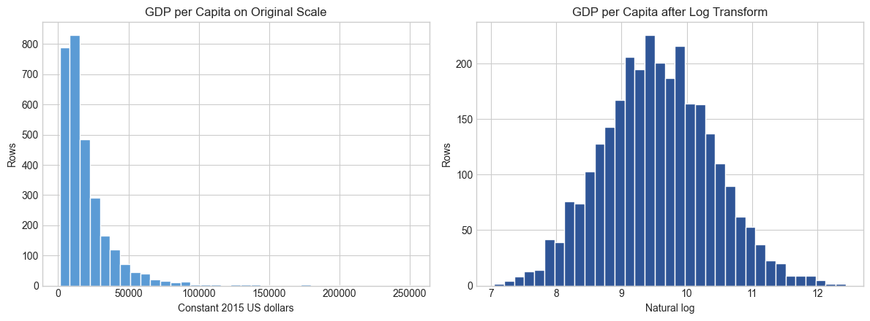
Figure 1: Distribution of GDP per Capita (original and log scale)
The original GDP per capita is strongly right-skewed; the log transform gives a far more symmetric target, which suits linear regression.
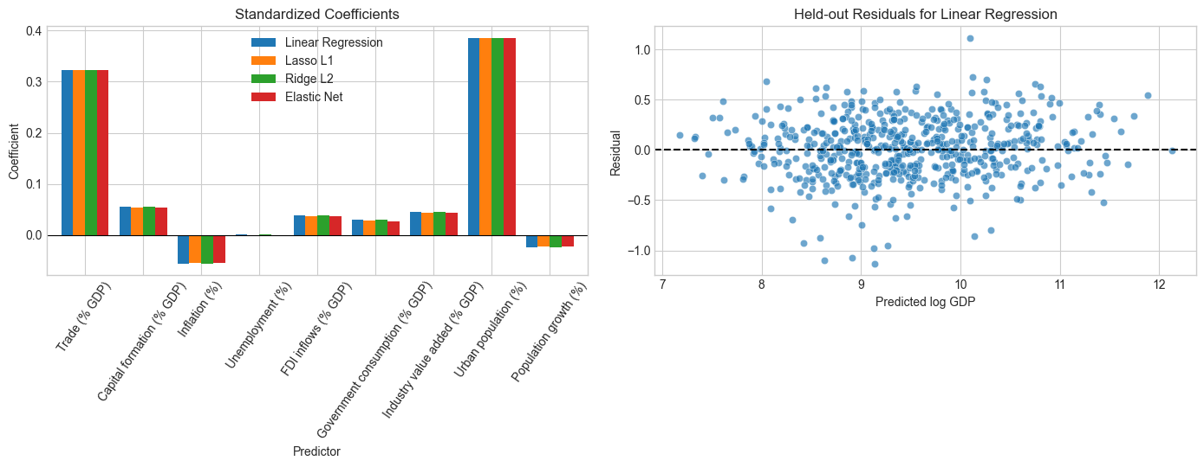
Figure 2: Standardized Coefficients and Held-out Residuals
Urban population and trade have the largest positive coefficients, and all four models give almost identical bars. Residuals of the best model are scattered around zero without a strong pattern.
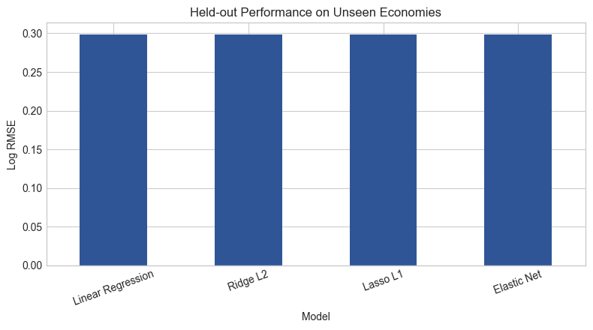
Figure 3: Held-out Performance on Unseen Economies
Y-axis → Log RMSE. All four models are practically tied at about 0.298.
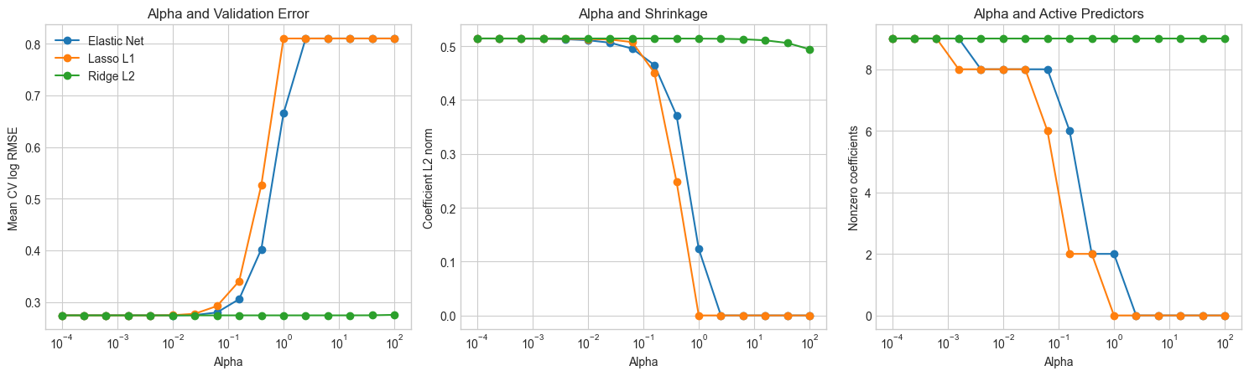
Figure 4: Effect of Alpha on Validation Error, Shrinkage and Active Predictors
X-axis → Alpha (log scale). Lasso and Elastic Net validation error stays flat for small alpha, then rises sharply as predictors are removed, while Ridge stays almost flat because it shrinks without zeroing coefficients.

Parameter Modification
S. No. | Parameter | Original Value | Modified Value | Original Result | Modified Result | Observation
1 | Penalty type | Linear (no penalty) | Lasso L1 | Test log RMSE = 0.2980; 9 non-zero coef. | Test log RMSE = 0.2985; 8 non-zero coef. | Unemployment coefficient set to zero; error almost unchanged
2 | Penalty type | Linear (no penalty) | Ridge L2 | Test log RMSE = 0.2980; L2 norm = 0.5142 | Test log RMSE = 0.2981; L2 norm = 0.5129 | All 9 predictors kept; coefficients slightly shrunk
3 | Penalty type | Linear (no penalty) | Elastic Net | Test log RMSE = 0.2980; 9 non-zero coef. | Test log RMSE = 0.2987; 8 non-zero coef. | Sparse like Lasso; marginally higher error
4 | Lasso alpha | 0.0032 (tuned) | 1.0 | CV log RMSE = 0.2739; 8 non-zero coef. | CV log RMSE ≈ 0.81*; 0 non-zero coef. | Too strong a penalty removes all predictors (underfitting)
* Read from Figure 4 (not printed numerically in the notebook output).

Analysis and Conclusion
- Regularization did not improve prediction here. Linear Regression had the lowest held-out log RMSE (0.2980); Ridge (0.2981), Lasso (0.2985) and Elastic Net (0.2987) were practically identical, with R² ≈ 0.903 for all. With only nine predictors and over 2,300 training rows, there is little variance for a penalty to remove.
- L1 and Elastic Net performed feature selection: both set the Unemployment coefficient to exactly zero (8 non-zero coefficients), consistent with its near-zero value (0.0015) in the unpenalized model. Ridge kept all nine predictors.
- Urban population (≈ 0.386) and trade (≈ 0.323) dominate the model; inflation (≈ −0.057) and population growth (≈ −0.024) have small negative coefficients.
- Penalties shrink the coefficients slightly (L1 norm 0.9597 → 0.9458 for Elastic Net), but excessive alpha hurts: for Lasso, validation error rises to about 0.81 once alpha reaches 1 and all coefficients are zero, whereas Ridge is almost insensitive across the whole grid.
- The median absolute percentage error is about 19% and the results describe prediction, not causation.
- Problem + Algorithm
Experiment No.: 12
Title: Kernel PCA (RBF) versus Ordinary PCA for Income-Group Classification
Aim:
Implement RBF Kernel PCA, compare it with ordinary PCA and with the raw standardized features for classifying economies as high-income or not, and study the effect of the kernel parameter gamma.
Problem Statement:
Ordinary PCA can only find linear directions of variation. If income groups are separated by non-linear structure in the macroeconomic indicators, Kernel PCA may give a better two-dimensional representation. Using a World Bank cross-section of economies (the latest year with at least 150 classified economies and 25 high-income economies), reduce nine macroeconomic indicators to two components with PCA and RBF Kernel PCA, classify High income (HIC) versus non-high income (LIC/LMC/UMC) with logistic regression, and compare against a model trained on all nine standardized features.
Algorithm:
- Keep economies with a classified income level and at least 6 of the 9 indicators available.
- Select the latest year with at least 150 economies and 25 high-income economies (2023) and create the binary target high_income.
- Split the data into 75% training and 25% testing using stratified sampling.
- Build three pipelines: (i) imputation → standardization → logistic regression; (ii) … → PCA (2 components) → logistic regression; (iii) … → RBF Kernel PCA (2 components) → logistic regression, all with balanced class weights.
- Tune gamma over 13 values from 10⁻³ to 10¹ using 5-fold stratified cross-validation with balanced accuracy.
- Evaluate the three methods on the test set: balanced accuracy, macro F1, ROC AUC and confusion matrix.
- Plot the two-dimensional embeddings with the decision boundary and the gamma-sensitivity curve.
- Report the comparison and conclusion.
- Program
Important code sections, function definitions, core algorithm and key parameter settings are given below. The complete executable program (Q12_Kernel_PCA.ipynb) can be maintained digitally through GitHub.
Libraries and key parameter settings
import numpy as np, pandas as pd, matplotlib.pyplot as plt
from sklearn.decomposition import KernelPCA, PCA
from sklearn.impute import SimpleImputer
from sklearn.linear_model import LogisticRegression
from sklearn.metrics import (balanced_accuracy_score, confusion_matrix, f1_score,
roc_auc_score)
from sklearn.model_selection import GridSearchCV, StratifiedKFold, train_test_split
from sklearn.pipeline import Pipeline
from sklearn.preprocessing import StandardScaler

RANDOM_STATE = 42
DATA_PATH = "world_bank_macro_2010_2023.csv"
FEATURES = ["trade_pct_gdp", "gross_capital_formation_pct_gdp",
"inflation_consumer_pct", "unemployment_pct", "fdi_net_inflows_pct_gdp",
"government_consumption_pct_gdp", "industry_value_added_pct_gdp",
"urban_population_pct", "population_growth_pct"]

Data selection and stratified split
raw = pd.read_csv(DATA_PATH)
classified = {"LIC", "LMC", "UMC", "HIC"}
candidates = raw.loc[raw.income_level_code.isin(classified)
& (raw[FEATURES].notna().sum(axis=1) >= 6)].copy()
coverage = candidates.groupby("year").agg(rows=("country_code", "size"),
high_income=("income_level_code", lambda v: int((v == "HIC").sum())))
eligible = coverage.query("rows >= 150 and high_income >= 25").index
selected_year = int(max(eligible)) # -> 2023
data = candidates.loc[candidates.year == selected_year].copy()
data["high_income"] = (data.income_level_code == "HIC").astype(int)

X, y = data[FEATURES], data.high_income
X_train, X_test, y_train, y_test = train_test_split(
X, y, test_size=0.25, stratify=y, random_state=RANDOM_STATE)

Core algorithm: pipelines and gamma tuning
def logistic():
return LogisticRegression(max_iter=5_000, class_weight="balanced",
random_state=RANDOM_STATE)

raw_pipeline = Pipeline([("impute", SimpleImputer(strategy="median")),
("scale", StandardScaler()), ("classifier", logistic())])
pca_pipeline = Pipeline([("impute", SimpleImputer(strategy="median")),
("scale", StandardScaler()), ("reduce", PCA(n_components=2)),
("classifier", logistic())])
kpca_pipeline = Pipeline([("impute", SimpleImputer(strategy="median")),
("scale", StandardScaler()),
("reduce", KernelPCA(n_components=2, kernel="rbf",
eigen_solver="arpack")),
("classifier", logistic())])

cv = StratifiedKFold(n_splits=5, shuffle=True, random_state=RANDOM_STATE)
gamma_grid = np.logspace(-3, 1, 13)
search = GridSearchCV(kpca_pipeline, {"reduce__gamma": gamma_grid},
scoring="balanced_accuracy", cv=cv, n_jobs=-1,
return_train_score=True)
search.fit(X_train, y_train)
raw_pipeline.fit(X_train, y_train)
pca_pipeline.fit(X_train, y_train)
best_gamma = float(search.best_params_["reduce__gamma"])

Evaluation and embedding function
models = {"Raw standardized features": raw_pipeline, "Ordinary PCA": pca_pipeline,
"RBF Kernel PCA": search.best_estimator_}
rows, matrices = [], {}
for name, pipeline in models.items():
pred = pipeline.predict(X_test)
probability = pipeline.predict_proba(X_test)[:, 1]
matrices[name] = confusion_matrix(y_test, pred)
rows.append({"Method": name,
"Balanced accuracy": balanced_accuracy_score(y_test, pred),
"Macro F1": f1_score(y_test, pred, average="macro"),
"ROC AUC": roc_auc_score(y_test, probability)})
comparison = pd.DataFrame(rows).set_index("Method")

def transform(pipeline, values): # 2-D embedding used for the plots
values = pipeline.named_steps["impute"].transform(values)
values = pipeline.named_steps["scale"].transform(values)
return pipeline.named_steps["reduce"].transform(values)

- Output + Analysis
Dataset and Configuration:
Dataset: World Bank World Development Indicators cross-section
Selected Year: 2023 (210 economies)
Target: high_income = 1 if income level is HIC, else 0
Train/Test Split: 75% / 25%, stratified (random_state = 42)
Reduced Dimensions: 2 components
Gamma Grid: 13 values, 10⁻³ to 10¹ (RBF kernel)
Cross-Validation: StratifiedKFold, 5 folds, scoring = balanced accuracy

Program Execution
Execution Status: Successfully Executed
Economies by income group (2023):
Income group | Economies
High income | 190
Upper middle income | 17
Lower middle income | 3

Missing values in predictors:
Predictor | Missing (%)
trade_pct_gdp | 1.4
gross_capital_formation_pct_gdp | 1.9
inflation_consumer_pct | 1.4
unemployment_pct | 2.4
fdi_net_inflows_pct_gdp | 2.9
government_consumption_pct_gdp | 2.9
industry_value_added_pct_gdp | 3.3
urban_population_pct | 4.8
population_growth_pct | 1.0

Stratified train/test split:
 | Training | Testing
Non-high income | 15 | 5
High income | 142 | 48

Test-set performance of the three methods:
Method | Balanced accuracy | Macro F1 | ROC AUC
Raw standardized features | 0.9479 | 0.8059 | 0.9875
Ordinary PCA | 0.8958 | 0.6919 | 0.9792
RBF Kernel PCA | 0.8750 | 0.6558 | 0.9625

Confusion matrix counts on the test set (read from Figure 1):
Method | Non-high → Non-high | Non-high → High | High → Non-high | High → High
Raw standardized features | 5 | 0 | 5 | 43
Ordinary PCA | 5 | 0 | 10 | 38
RBF Kernel PCA | 5 | 0 | 12 | 36

Gamma sensitivity (5-fold cross-validation):
Gamma | Mean train balanced accuracy | Mean CV balanced accuracy | CV std. dev.
0.0010 | 0.8668 | 0.8556 | 0.0896
0.0022 | 0.8668 | 0.8556 | 0.0896
0.0046 | 0.8642 | 0.8556 | 0.0896
0.0100 | 0.8791 | 0.8521 | 0.0854
0.0215 | 0.8756 | 0.8818 | 0.0816
0.0464 (selected) | 0.8703 | 0.8854 | 0.0748
0.1000 | 0.8628 | 0.8521 | 0.0765
0.2154 | 0.8632 | 0.8415 | 0.0838
0.4642 | 0.7444 | 0.7483 | 0.1550
1.0000 | 0.6023 | 0.5392 | 0.1096
2.1544 | 0.5423 | 0.4964 | 0.0071
4.6416 | 0.5097 | 0.5000 | 0.0000
10.0000 | 0.5202 | 0.5000 | 0.0000

Program output:
Selected year: 2023
Economies: 210
Selected gamma: 0.0464159
Mean CV balanced accuracy: 0.8854
Conclusion: On held-out 2023 economies, RBF Kernel PCA performed worse than ordinary PCA. Its balanced accuracy was 0.875, versus 0.896 for ordinary PCA. The unreduced nine-feature baseline scored 0.948, showing the predictive information lost when either method compresses the data to only two dimensions. Gamma=0.0464159 was selected only from training folds. This result is specific to this cross-section and does not imply causation or universal nonlinear income-group structure.
Saved results\metrics\q12_kernel_pca_world_bank.json

Result Graphs
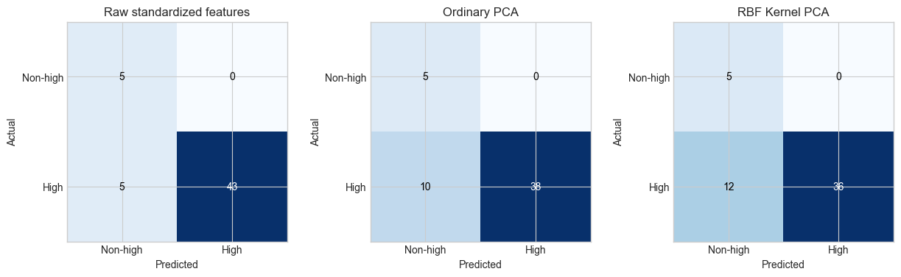
Figure 1: Confusion Matrices of the Three Methods
All methods classify every non-high-income test economy correctly; the errors are high-income economies predicted as non-high (5 for raw features, 10 for PCA, 12 for Kernel PCA).
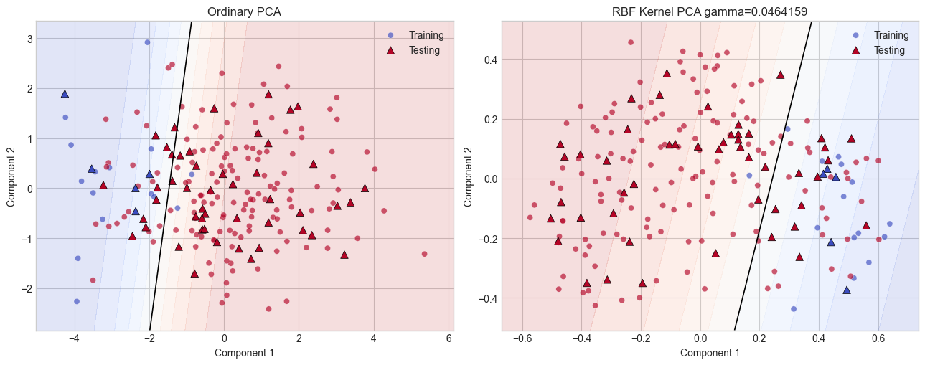
Figure 2: Two-Dimensional Embeddings and Decision Boundaries
X-axis → Component 1; Y-axis → Component 2. Triangles are test economies, circles are training economies; the black line is the 0.5 probability boundary. Both embeddings are separated mainly along Component 1 by an almost linear boundary, with no clear gain from the non-linear kernel.
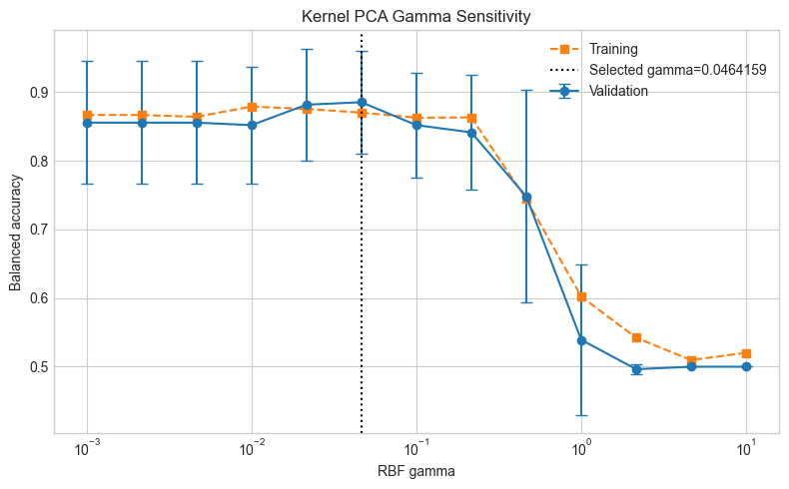
Figure 3: Kernel PCA Gamma Sensitivity
X-axis → RBF gamma (log scale); Y-axis → balanced accuracy. Validation accuracy peaks near gamma = 0.046 and collapses to chance level for large gamma.

Parameter Modification
S. No. | Parameter | Original Value | Modified Value | Original Result | Modified Result | Observation
1 | RBF gamma | 0.0464 | 0.001 | CV bal. acc. = 0.8854 (train 0.8703) | CV bal. acc. = 0.8556 (train 0.8668) | Very smooth kernel; slightly lower accuracy
2 | RBF gamma | 0.0464 | 0.2154 | CV bal. acc. = 0.8854 (train 0.8703) | CV bal. acc. = 0.8415 (train 0.8632) | Kernel becoming too local; accuracy drops
3 | RBF gamma | 0.0464 | 1.0 | CV bal. acc. = 0.8854 (train 0.8703) | CV bal. acc. = 0.5392 (train 0.6023) | Embedding loses class structure; near chance
4 | RBF gamma | 0.0464 | 10 | CV bal. acc. = 0.8854 (train 0.8703) | CV bal. acc. = 0.5000 (train 0.5202) | Chance-level performance
5 | Reduction method | RBF Kernel PCA | Ordinary PCA | Test bal. acc. = 0.8750 | Test bal. acc. = 0.8958 | Linear PCA slightly better on this data
6 | Input representation | RBF Kernel PCA (2-D) | All 9 features (no reduction) | Test bal. acc. = 0.8750 | Test bal. acc. = 0.9479 | 2-D compression loses predictive information

Analysis and Conclusion
- The best gamma was 0.0464, giving a mean cross-validated balanced accuracy of 0.8854. Accuracy is fairly stable (0.84–0.88) for gamma up to 0.2154.
- On the test economies, RBF Kernel PCA (balanced accuracy 0.875, macro F1 0.656, ROC AUC 0.963) did not beat ordinary PCA (0.896, 0.692, 0.979); the unreduced nine-feature model was best (0.948, 0.806, 0.988). So nothing was gained from the non-linear kernel on this cross-section.
- The difference is small in absolute terms: the test set has only 5 non-high-income economies, and Kernel PCA misclassified 2 more high-income economies than PCA (12 versus 10 of 48).
- For gamma ≥ 1 the training score also falls toward 0.5, so the failure is a loss of class structure in the embedding rather than overfitting.
- The results are specific to this 2023 cross-section with a small non-high-income group (20 of 210 economies) and do not establish causation or a universal non-linear income-group structure.

